Final Year Project: Gogreen carpooling application for Android Users.

Software Engineering BSc



Project supervisor: Dulari Bhatt

Second Marker: Alex Fasnmade

Author: Sairah Ahmed

De Montfort University

2020

**Acknowledgments**

In the name of Allah, the Most Beneficent, the Most Merciful. I would like to start by expressing my gratitude to the most important, Allah the Almighty for supporting me throughout this challenging time and always showering his blessings upon me. I would also like to thank my parents and grandma for supporting and encouraging me to do my best throughout this crucial time. I would also like to thank my siblings and aunties for the love and support they have shown me. I would like to express the deepest appreciation to Dulari Bhatt my supervisor who has supported me throughout the year, without your guidance I would not have been able to complete this report or project. Finally, I would like to thank all my friends; Amina, Layla, Abu-Bakr, and Ahmed, for all the help you have given me throughout the last 3 years, I know I would be lost without you guys. Thank you for all the care and support everyone has shown me throughout the year.

**Abstract:**

As I have mentioned before the transport industry is growing rapidly, especially in the sector where companies that provide a carpool service for the riders. The competition has increased hugely among big competitors like Uber and lyft. For my application to stand out I decided to pick the niche market, which was to develop an app for hybrid cars only called Gogreen for android users. This app was developed in android studio with the chosen language java and I used firebase for the database of this app. This app in simple words will let the user search for a ride and book hybrid cars. This process of how I developed the application will all be discussed in the report section by section.

Contents Page

1. **Introduction…………………………………………….**
   1. Project Overview Page 4
   2. Project Map Page 5
2. **Research………………………………………………….**
   1. Aim Page 6
   2. Findings Page 6

1. **Analysis…………………………………………………**
   1. Introduction Page 7
   2. Hardware & Software Requirements Page 7
   3. Software Development Methodology Page 7
   4. Waterfall Page 8
   5. Agile Page 8
2. **Design………………………………………………….**
   1. Introduction Page 11
   2. System design & Architecture Page 11
   3. Entity relationship diagram Page 11
   4. Use case diagram Page 12
   5. Android mobile application design Page 13
3. **Implementation……………………………………………**
   1. Introduction Page 15
   2. Software & hardware Page 16
   3. User components Page 16
4. **Testing………………………………………………………**
   1. Introduction Page 20
   2. Performance testing Page 21
   3. Use case Page 22
   4. Use case testing table Page 22

1. **Critical Evaluation………………………………………** Page 23
2. **Conclusion………………………………….** Page 25

# 1 Introduction

.

Over the last decade, the expansion in the use of vehicles has expanded quickly. The use of transport has increased due to the easy access it has as well as it being very convenient, there are now many new forms of transportation for example carpooling. In carpooling it allows the users to travel with one or more individuals in one ride. This report represents the mobile application development for Gogreen, which is a carpooling service provided to help solves and tackle these common issues this service is a platform for only hybrid cars. The challenges faced when developing this project will all be discussed in the critical evaluation underlining each stage's problem and how each was solved.

## Project Overview

This project aims to design an interactive carpooling application that will be named “Gogreen” for users that have android smartphones. Gogreen is a carpooling application that only hires vehicles with hybrid cars or electric cars and provides a service with these two cars. This project aims to provide an out of world experience for users, which will give them a glimpse of using a genuine mobile application for their smartphones. This report gives an inventory of results that all will be surveyed after each progression has been completed and will be cross-checked with the project contract. The expected outcomes of the project are listed below:

1. Android application that can sign users,
2. create bookings,
3. payment
4. Make profiles.
5. Easy use of the mobile application
6. Tools and software available to create the mobile application for example android studio.

## 1.2 Project Map

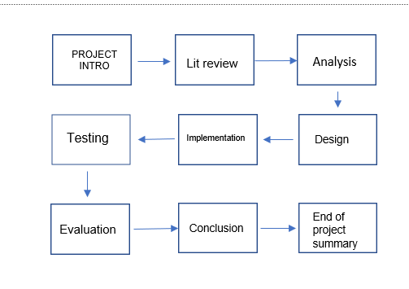



***Figure 1 Project map***

Figure 1 demonstrates the layout/steps for the project, it will start with an introduction that will present background information on the project chosen that was completed in the first deliverable the literature review. Furthermore, this report will break down and test the carpooling application that was made for android clients, which will all be critically evaluated with a conclusion. This layout will be used throughout the report as it gives a structure and is easy to follow. Each chapter will include detailed information for example, the Analysis will cover the best methodology that was used for the development of Gogreen.

# 2 Research

## 2.1 Aim

The demand for carpooling apps has increased precipitously since technology is developing every day. With so many mobile apps already available, this app must provide a new feature that other apps do not have. The literature review which was one of the first deliverables showed the gaps in the market for carpooling applications and companies. The most important key point for this project is that it can allow the driver to travel safely and for the customer to trust the driver. Furthermore, this project will help understand how mobile apps are created showing the process with the use of new software tools that will help this project.

## 2.2 Findings

In the literature review, it looked at how carpooling can be different and exclusive than other carpooling companies. For example, the development part of the app would need to consider what the gaps are in the market. After research, it is apparent that the lack of hybrid cars in the carpooling sector was the gap in the market and the option to allow the customers to pick their driver's gender. Due to the lack of carpooling applications with only hybrid cars it allowed me to pick this as my project due to it being in the niche market.

Due to the increase in mobile usage the two big companies’ apple and android competition has increased. However, in a recent article, it shows that androids are becoming immensely popular and are now used compared to Apple platforms (Piltch, 2017). Android has started to take over the mobile market by providing the best software for android devices and API. For the Android mobile development, the tools used will be an android studio, google maps API, and firebase for the database. The best methodology used for this project to be successful is the waterfall methodology. Due to the simplicity and each approach, this is the best method to use for the process of an android mobile application. This will be discussed in the methodology chapter.

The papers in the literature review show the demand for hybrid cars and how it is beneficial to carpool companies. However, there is a lack of apps that provide only hybrid cars for carpooling companies. The literature review also shows when developing the app what is important to consider in the mobile application. For example, one of the aspects that need to be considered when developing this app will be planning the app, using different methodologies, and asking for the user’s feedback to have a successful application throughout the development.

# 3 Analysis

## 3.1 Introduction

This chapter will discuss the functional and non-functional requirements to build a mobile application. The functional requirements are needed for this project as it is the fundamental foundation that will help create the mobile application. The non-functional requirements are useful in this because it covers other factors that are not needed to make the app. these requirements are important for the project as it is needed to have a successful application. This can be seen in the literature review that will be in the appendix.

## 3.3 Software Development Methodology

Software methodology is needed in every project as it has a process that starts with the planning, creating, and testing the project (Rachiele, 2018). There is a different methodology that can be used in projects, for example, agile, scrum, or waterfall which are the most popular and often used in development. When developing a mobile application that needs to be delivered within a time frame a large amount of work is completed in a few months or years depending on the delivery time set. This chapter will discuss the waterfall methodology from the mobile application development side and how it will be effective while discussing the pros and cons of this methodology.

## 3.4 Waterfall

“Dr. Winston W. Royce in a paper [published in 1970](http://www.cs.umd.edu/class/spring2003/cmsc838p/Process/waterfall.pdf), the waterfall model is a software development process” (Powell-Morse, 2016). Waterfall methodology is a linear project management approach, where the customer's requirements and important information are taken at the start of the project. After collecting the information for the project, a sequential project plan is created to complete each requirement successfully and on time (Waterfall Methodology - Tools and Strategies - ProjectManager.com, 2020). The waterfall methodology uses stages for example each stage must be completed before the next stage, the requirements section must be reviewed by the developer to move onto the next stage (Lotz, 2018). Figure two shows the sequential of waterfall methodology.

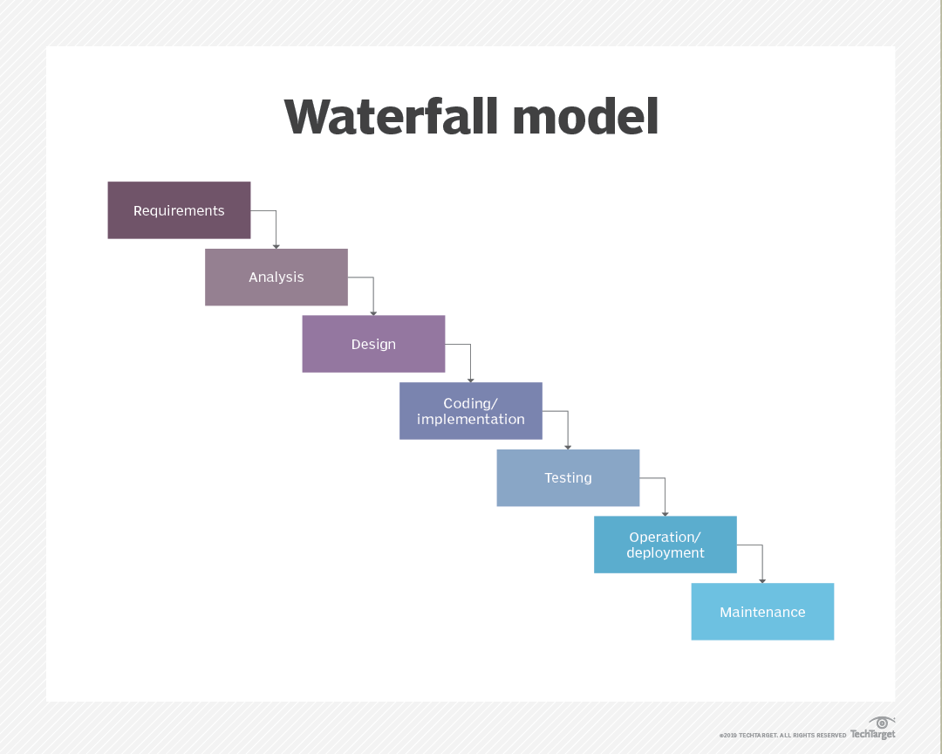

**Figure 2 (Rouse, 2019)**

Waterfall is a much more traditional methodology compared to agile it does have many advantages. One of the advantages of waterfall methods is that it allows the project team to work in a structured manner. This helps them ensure that the tasks are carried out efficiently and nothing is missed. It also allows them to keep on a fixed deadline, and they can work on each phase and only move onto the next phase once the current phase is complete. Additionally, due to waterfall allowing the team to work in stages and having to pass each stage to reach the next if team members decide to leave the project it will not affect the development. An advantage of choosing the waterfall methodology over agile is that the requirements are clearly stated at the beginning of the development and will remain the same throughout the project development. Another advantage of this method is that by having a structured approach to the project it allows everyone to understand the process as it requires the individuals to work step by step and making it easy to work time efficiently (Gallagher, Dunleavy and Reeves, 2019). Furthermore, another advantage of this model is that the start and end goals for each section is set, this made it easy to measure my progress (Waterfall Methodology: Advantages and Disadvantages, And When to Use It? 2018). Finally, the software that is created can be created in detail and carefully and create a better software design as it allows the developers to work in stages (Lotz, 2018).

However, there are many disadvantages to the waterfall method as it can make the requirements stage difficult. For example, if a company would like to change the spec this would take a long time to adapt as the project will need to return the beginning to the requirement stage. Therefore, making it very time consuming (Gallagher, Dunleavy, and Reeves, 2019). Another disadvantage of using the waterfall method is that client is unable to try the software until it has all been completed. Furthermore, by using this method it is difficult to estimate the total time a project will take to complete. Due to each company having different processes there may be different issues they encounter for example some team workers may leave halfway through the development process, this will cause long delays in finding a replacement and lead to slow progress in making the software (Gallagher, Dunleavy, and Reeves, 2019). Finally, there may be an issue with the flexibility of the project as when placing new developments, it will require the developer to go back to the requirements part after each change. Also due to the changes happening in the world every day in the market, they may not have taken this into account when planning the project upfront (Kienitz, 2017).

## 3.5 Agile

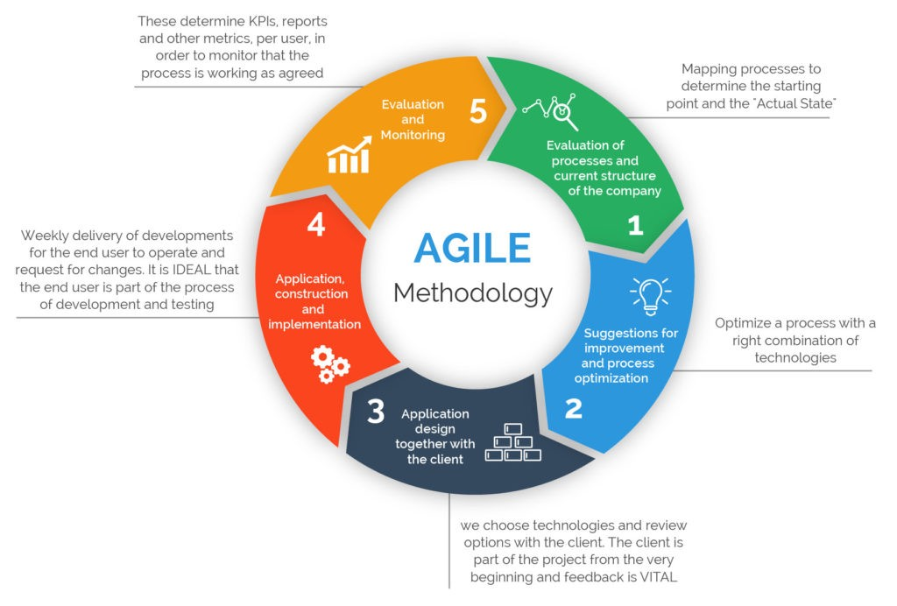

**Figure 3 (Reddy, 2019)**

Agile methodology is a team-based method for the development of a project. This method is known for its rapid response to changes and completion as it is a more functional approach compared to the waterfall methodology. Agile does not work in steps it uses something called “sprints”, each “sprint” has a specific task that is planned at the beginning of the spring that will need to complete within weeks rather than a slower pace like the waterfall (Lotz, 2018).

The advantage of using the agile method is that the client can see the development of the product very early which leads them to give the developer feedback on the project for any changes throughout the project. Furthermore, it allows the clients to gain ownership by working with the project throughout the project (Lotz, 2018). On the other hand, the disadvantages of picking the agile method are agile project may not be as organized as the waterfall method if the team does not work together efficiently and according to the plans. Also, there is a lot of time spent sprint planning in meetings which can be very time consuming and strain money.

Overall, the best method for the development of the mobile application of the Gogreen Carpooling app is the waterfall methodology. This is due to the simplicity of the method and the easy use of the cycle. As discussed in the introduction of this chapter waterfall method has 5 stages which are requirement, design, implementation, verification, and maintenance. By using this method, it will allow the application to be developed and completed in phases one at a time; this makes it a lot easier to manage and plan the project effectively. The waterfall methodology also enables the developers of the mobile app to get an estimate of how much the development may cost and therefore can adjust certain requirements (Gallagher, Dunleavy, and Reeves, 2019). Finally, the waterfall methodology is more suitable for me as I am alone developing the Gogreen app.as opposed to the agile methodology which would require at least a small team. This is because of agile delegates different tasks to different people. Waterfall’s method used in this are listed below:

* **Requirements:** This is the first stage for any project. The software needed to produce the app for example android studio. What the app needs to complete each step of the way to create a successful app.
* **Design:** The design stage is creating the architecture for the mobile application, which

will cover functional and non-functional requirements that suit the user the best.

* **Implementation:** The implementation stage is the most important as the developer will need to create, code, implement, and test the code.
* **Verification:** To allow verification in the app for example logging in for the customers will be confirmed via an email address that will allow the user to access the app vice versa for the drivers.
* **Maintenance:** The waterfall model only allows the user to move on to the next stage until the previous stage has been completed successfully (Gallagher, Dunleavy, and Reeves, 2019).

# 4 Design

## 4.1 Introduction

This design chapter will cover the requirements needed to produce and explain the system architecture. The design is very important for the development of the mobile application this will be shown in the report via many different diagrams that were created for the report. It is very important to able to present the documents as it will help keep track of the app's process as it will cover the user interface designs and the structure of the system.

## 4.2 System Design & architecture

At the start of this report figure, 1 was created to provide a clear understanding of the system architecture which has been chosen for this project. For this to be a successful mobile app, it will need to take in mind the requirements. Furthermore, for the app to work successfully without any errors the application must have a cloud database for the customer authorization and details. The reason why a database is needed will be for the users to use when logging in the app for the customer's side. The cloud database used in this project was google firebase. the use of firebase will help the user’s authentication which will provide a safe way of transferring data, without worrying about any security breaches being placed. This all will be applied by android as it is the most popular compared to iOS. Google Maps API will be used for the location data by using google maps it will allow the user to access the app location all around the world and is easy to implement in this project.

## 4.3 Entity relationship diagram

The entities used in this diagram are shown in figure 4 below. By using the ERD diagram it will allow the user to understand how the background design and development of Gogreens’s carpooling mobile application will work without having to start the project. I have used the ERD diagram as it is easy to understand and is very simple to create for a project like mine. Entity diagrams are very important for any project or business as it is very easy to manage data in an effective manner (DREAMS, 2016). Furthermore, by using this diagram it will allow the developers or users to understand how each database is linked to the information in the table. For example, the user can request a ride to the driver, this will allow the rider to request as many riders from more than one user. This ERD diagram is much more developed compared to the one I submitted in the first deliverable. ERD diagram is an important feature as it allows me to see the data and information needed for my software development. This diagram will help me use each feature in the flow diagram efficiently in my system. Furthermore figure 4 shows the rider will send a ride request to the driver and will accept it with details of the car being sent to the rider.

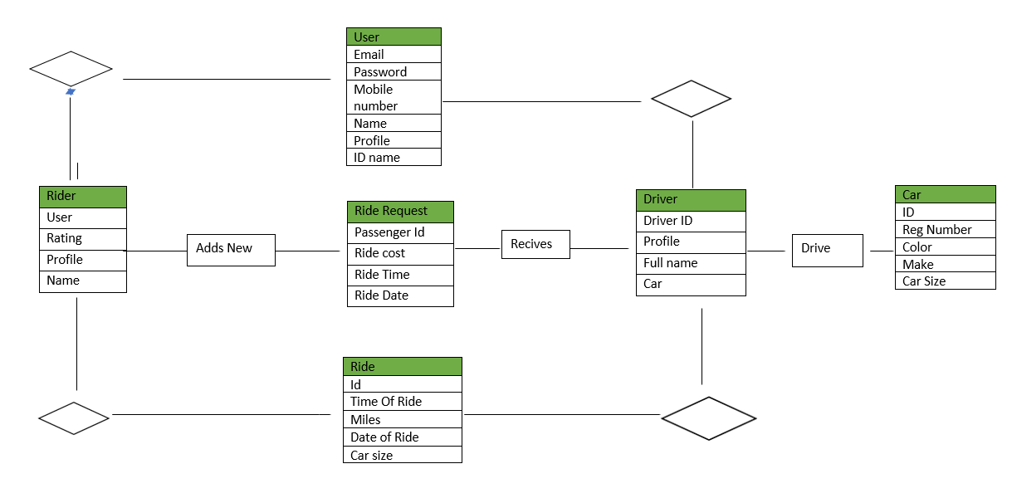

***Figure 4 ERD***

## 4.4 Use Case Diagram

A use case diagram will be used; it will be created based on the functional and non-functional table of requirements which can be found in my first deliverable submission, literature review. By using a diagram like the use case, it will make it easier for me or the user to understand how each interaction is made with the system by the user. Furthermore figure 5 shows Gogreen carpooling systems with each interaction that occurs with the system and the user. The figure shows the user has three use cases which are login, profile, and managing the Gogreen application. With the help of this diagram, I will be able to describe the functional requirements of the system and it allows the user to try various routes that will help improve the development of the app. The use of this diagram benefited my project as it allowed me to understand my project much clearly and showed how each path interacts with the other path. For example, the system must authorize the user which is then confirmed and will then allow the user to login to the application.

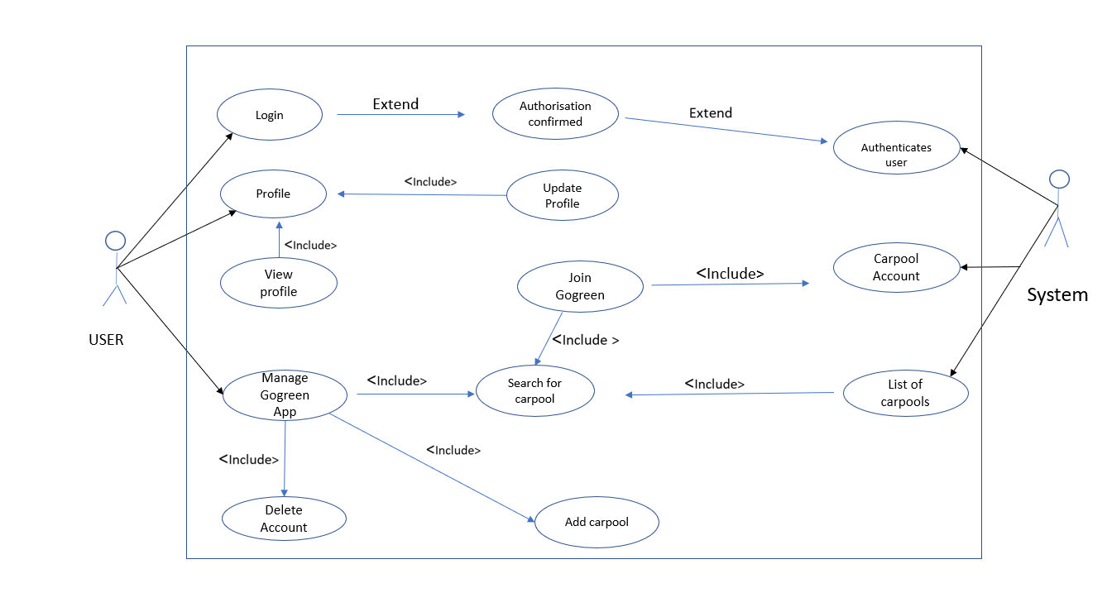

Gogreen Use Case Diagram

***Figure 5***

## 4.5 Android Mobile Application Design

The app that I have created had to focus on what the user wanted and how they could interact with the application. The Gogreen android application will allow the user to register and login to the app, which will result in the user being able to book or create a ride. This is the same process for the driver who will be able to create a profile and have the option of clicking the working button which will then allow the driver to start working. This application will need to implement the functional and non-functional requirements that are listed below. The table below shows each user's activity will need to function to have a fully functioning application. The design of my application is made very simple and has large buttons with colours that are contrasting the login in page. I have used large headings in my login page for the user, so it is clear where they need to type. I decided to keep the font as Arial and size 12 throughout the app as it is the clearest font and popular.

|  |  |
| --- | --- |
| *Register* | * *This will allow the user to register for the app by using their details to access Gogreen carpooling application.* |
| *Login* | * *The login will be launched once registering has been completed. The user will need to enter their details and password for the app to access it. Once it has been authorized the user will be able to use the app.* |
| *Main app* | * *Once in the main app, the user will have to allow access to their current location and will show google maps in the background. It will also have a navigation menu to search for a ride.* |
| *Profile* | * *This will allow the users to insert their details for their profiles. For example, it will give the user an option to insert a picture name, etc, and for the driver their car details.* |
| *Edit profile* | * *.Both users will be able to change their details as soon as they have logged into the application.* |
| *Find ride* | * *The user will be able to search for their ride by typing in the navigation bar.* |
| *Create ride* | * *The user will be able to search and create a destination they would like to make.* |
| *Pick car* | * *The rider will get a choice of what car they would like to use for example gogreenx or gogreenxl depending on the number of passengers a vehicle can take.* |

***Table of Gogreen Android App***

## 4.6 Conclusion

The design chapter shows two diagrams and one table that provides detail into this project and the required outcomes. The next chapter which is implementation will cover the tools used for example the software and hardware used to develop my application. This chapter shows the developer what requirements are needed for this app to work.

# 5 Implementation

## 5.1 Introduction

This chapter will cover the implementation side of the mobile application and will cover all the development tools that were used for example the software choice for this project and why this was the best for the project compared to the other software available. User components which are the next section are one of the most important factors for the development of the application as it is one of the steps that is needed for this project. This section will also cover the hardware that was used this will be provided by screenshots and any code relevant for this section will be shown.

## 5.2 Software & Hardware:

The software I decided to use for this project was Java due to the popularity it had in creating a mobile application in android studio. Developing mobile applications has become very popular due to the ease of access to software such as android studio. Android studio allowed me to build my application from scratch and allowed me to use the language I wanted to program in. The language I picked to develop my carpooling app for hybrid cars only was Java. One of the reasons I picked Java was due to the increased security it has for my platform and the language itself (viz, 2015). Due to Java focusing on security, it allowed me to follow YouTube tutorials and use the code in an android studio without infecting the host system that may cause a virus or a malware issue. Another reason why I picked Java for my project was that the language is not very complex and simple to use as it provides a different set of APIs which helped my development of Gogreen enormously. Furthermore, using java allowed me to use the language on different computer systems, this helped me work on my code when I did not have access to my laptop. Java is a language that is used vastly across the world. This is because when I would come across an error, I was able to find a solution for it quickly as it is used by many others and there are always people who would help online. Due to the popularity of this language, I had a successful and easy journey in completing my android application. Finally, the reason java is one of the best languages when developing an android application is it is an object-oriented language that gives the user flexibility when in use (viz, 2015). I used android studio software as it had more accurate programming and would provide me with shorter ways of typing in the code, it would remove what was needed and what was not. in other words, it provides shortcut and efficient ways to code.

**HARDWARE**

The hardware used in my project was my laptop the Lenovo yoga 700-14isk which runs on windows 10. My laptop has intel core i7 with 8GB RAM with 256gb SSD, also the laptop provides a resolution of 1920 x 1080. The advantage of my laptop using the operating system Windows 10 for this project is the ease of use it gives the user when transferring from window 7 as all the features are the same. Windows 10 supports software like android studio that is used to develop my mobile application very easily and effectively. The large memory the laptop provides allows me to download my application and download any new software that I can use for android studio without worrying my storage will get full. The large 14’inch screen of my laptop allowed me to view my code more expansively compared to a laptop with a smaller screen.

## 5.3 User Components

This part of the report will discuss the functional requirements for Gogreen and what requirements are needed to make it fully functioning. Each function of the application will be discussed in detail with the necessary code placed under each heading, so it is easier to understand.

**User Registration:**

This is one of the most important parts of this mobile application and one of the first elements that start of my Gogreen mobile app. The user registration is one of the main functions needed for this application as it will allow the users to register their details to access the app. When creating the application, a profile class was made so that the user was able to make an account with their details via an email address and password. The methodology used was the water model this had 5 steps with one which was verification and second validation. This was used for the login and registration component of this project. The development tool for user registration and login was firebase. Firebase is a database that is used in java as it records the user’s detail and verifies it via this database and updates automatically in real-time. “Firebase is based on a data structure which is used by the NoSQL database and is much faster compared to MySQL” (Shukla, 2019).

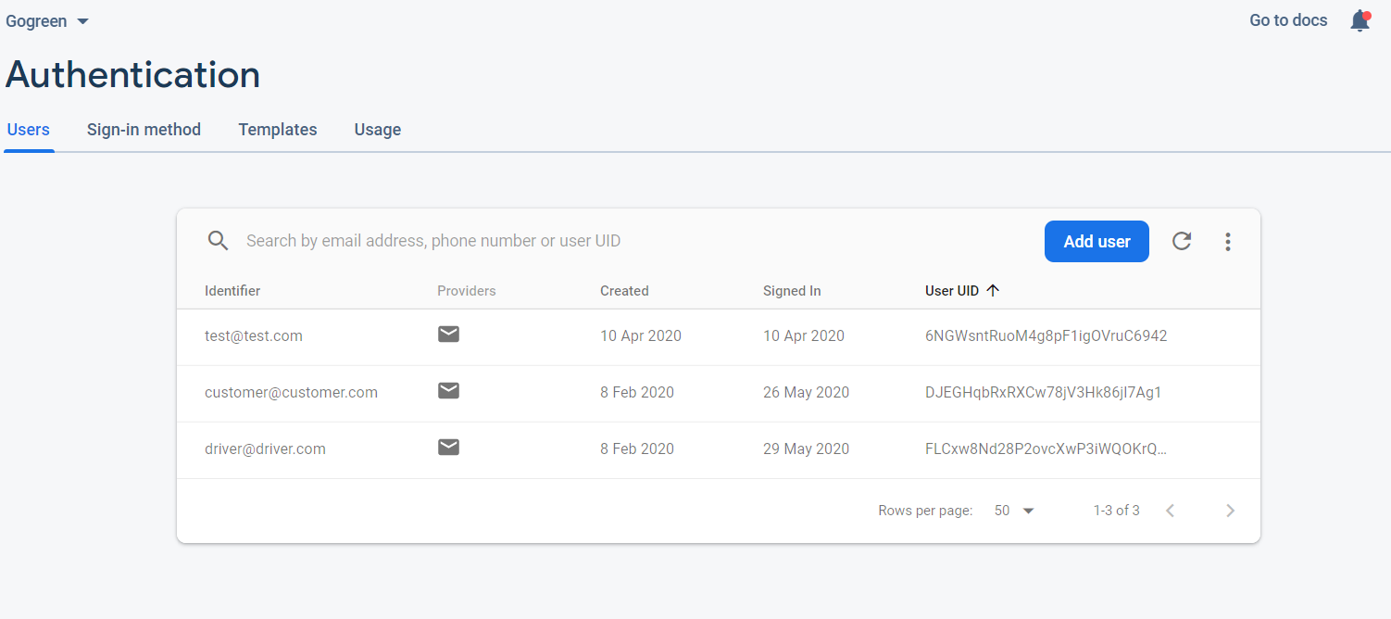 **Figure 7 firebase database Authentication**

The database shown in figure 7 shows that the users are given a (user ID) UID which is created by firebase, this will allow the user to access the mobile application. To make this app safe for the user I used firebase because It provides authorization via an email which is then verified and then allows access. This is done by firebase sending an email to the address with a link that will need to be clicked to verify it. Firebase provides security and protection from viruses and decreases the chances of my application from being hacked.

**User login:**

Figure 8 shows the background code used for the mobile application, which will allow the user to access my applications Gogreen services. This will be completed by logging in with an email address and password. Figure 9 shows the apps username and password entered. The code shows that if the login is successful the user will be able to login in successfully if not then an error message will show which is shown in the screenshot below. Figure 8 shows the code for the customer login and shows once the login has verified it will allow access to the user. Figure 9b which is linked to 9 shows what the user will see once login has been completed.

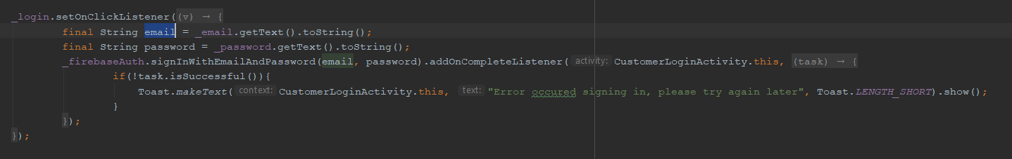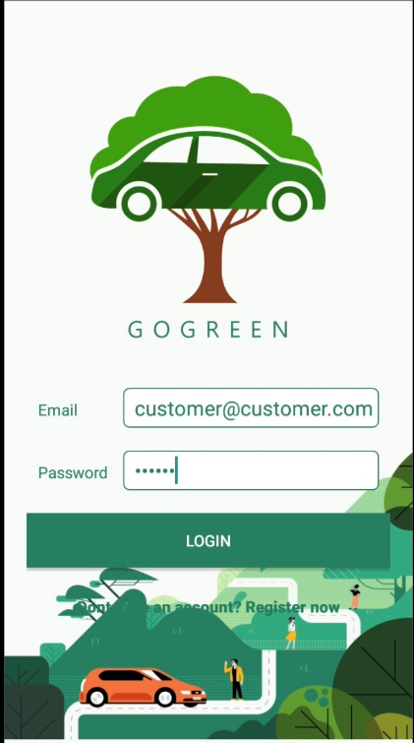***Figure 8***

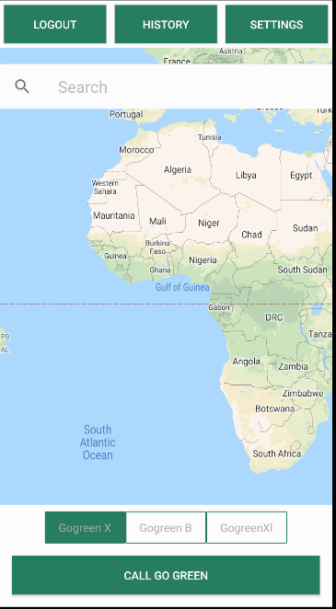

*Figure 9 Figure 9B*

**Booking system of Gogreen Carpooling Application:**

Gogreen booking framework is one of the most significant pieces of this application as it permits the clients to book rides. When building up this application, I chose to utilize firebase for the database if this application would get mainstream, and more than one client will utilize it. In this way, firebase will have the option to hold in more rider's data as it is the host for this stage. The booking framework coding is separated in various stages each stage is a piece of an alternate gathering of classes. The three stages that are significant for this application are; firstly, the application should be able to search for a ride, second by utilizing google firebase database details will be confirmed and the last stage would show the rider their route has been acknowledged by the driver and accepted.

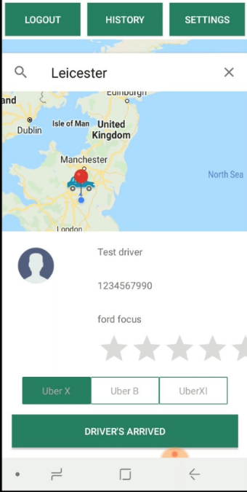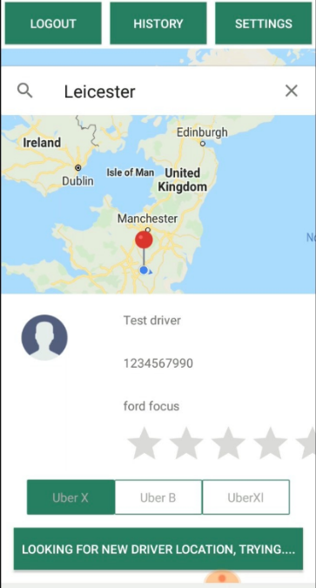



Gogreenx

*Figure 10 Booking system Figure 11 Booking system 2*

The user will only be able to search for a ride by allowing the mobile application to access their location by clicking allow or even by inputting the location in the search box shown in figure 10. I used to google maps API as it is very popular across the world and is used for many different carpooling apps like uber, lyft, and careem. For google maps to be implemented in my application, I had to permit the API for google maps location to work in my app. The screenshot below in figure 12 shows the code required. The reason why I used this code was it the customer location will only be accessible if the customer will allow the location to be available. The code shows when the customer allows permission the system will show their exact location using google maps. After the customer has logged in, they will be the main activity where they will be able to use the app with ease.

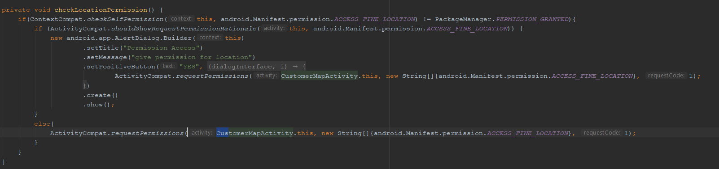 *Figure 12*

# *6 Testing*

## 6.1 Introduction

The testing of the software is used to investigate and conduct tests on the software created to find the quality of the software (Rajkumar 2020). The testing is a procedure to evaluate the usefulness of a created programming application like Gogreen, this is completed by cross-checking the software to the requirements with the software development life cycle. The software development life cycle (SDLC) has five main cycles and the fourth cycle is testing as it is one of the most important parts when developing software for a large company. Testing will allow the developers to test the software and adjust any component to achieve the best quality of software that meets the companies’ requirements. The two tests that I used were performance testing and unit testing for my application.

## 6.2 Performance Testing

This type of testing is a performance test on the mobile application and is one of the most important tests that can be done. I used performance testing for Gogreen because it shows me how my application would run under specific conditions. For example, the application may run perfectly for 2,000 users however on the 3,001 users an error may occur in the application. By using this process, it allows me to identify issues I have in my systems in hindsight improve the overall system. By improving the system, will help improve the user's experience when using the Gogreen carpooling application and in the future, if this app is used worldwide it will increase my business revenue. Furthermore, the most common issue I came across was bottlenecks, this is when there is an increase in traffic and the servers are not able to handle too much traffic in the data flow. Therefore, if I had not tested, I would not know about this issue and in the future, it would impact my application performance hugely. Figure 13 shows the CPU testing which is a central processor unit that is an important piece of the hardware part of the computer. this carries data and commands of programming to the hardware. Android studio allowed me to conduct the three main tests CPU, memory, and energy tests. Once I click run the application will run the tests will not stop until it has completed all the following tests. The tests were conducted on a Google Pixel 2XL API 28 emulator. Figure 13 shows the CPU test which tests the performance of the system when the application is running.

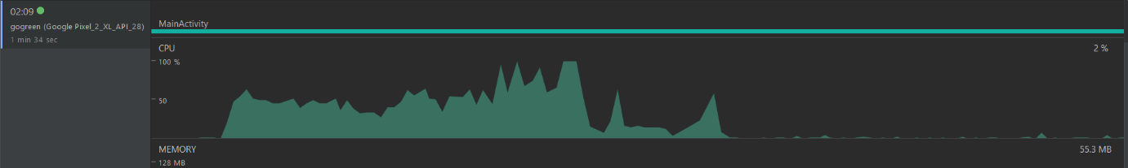*Figure 13 CPU testing*

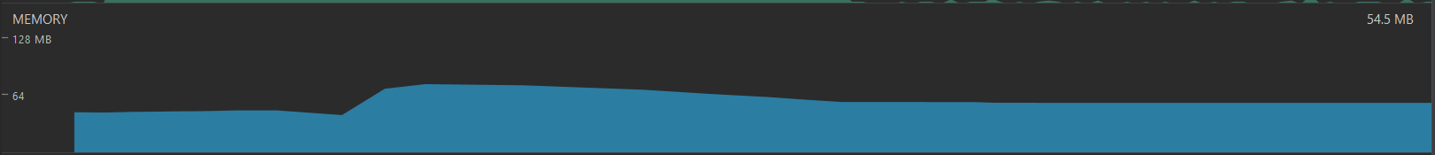

*Figure 14 Memory test*

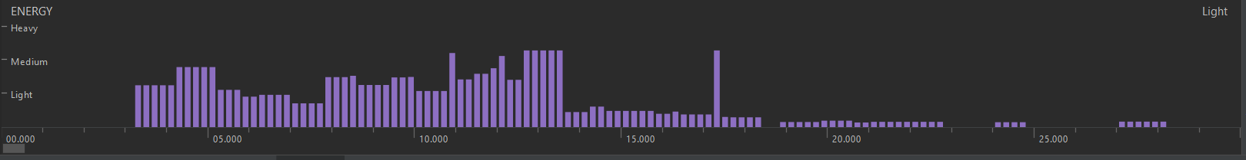

*Figure 15 Energy test*

## 6.3 Use case testing

Use case testing is known for testing the functionality of the system, this will help me understand and identify each function in my system and whether it was successful in meeting the requirements of the project contract. The use case testing allows the user to see the action performed by the user and how the system performs when the application is in use, this cannot be completed without both the user and system. Furthermore, the table created below will outline all the functions in my application with a box with a pass or fail option. I will show what function I was able to successfully input in my Gogreen carpooling application and what failed.

## Use case Testing Table

|  |  |  |  |  |
| --- | --- | --- | --- | --- |
| Use Case ID | How does it work? | Expected Result | The real outcome of the Result | Pass  /Fail |
| Login | The user should be able to login in with an email address and password | .The login will need to be successful and the user will be directed to the Home activity | The user was able to login successfully and entered the home activity | **PASS** |
| Register | The user can create an account by clicking and doesn’t have an account register. | Users should not have an account with an existing address and password. | The user was sometimes allowed to register but there was a problem with the database linking the code. | **FAIL** |
| Edit Profile | User should be able to edit their name and number etc | The user will need to be logged in the application to edit their profile | User can update their personal information. | **PASS** |
| Search for a ride | The user should be able to search for their ride by searching in the navigation bar. | The user will need to be logged in to complete this task | Users can search for a ride in the search navigation. | **PASS** |
| Book a ride | The user should be able to search and book their ride by using the search bar and chose the car they want. | The user will be able to book a ride and the driver can to.decline or accept the booking | The user was able to book the ride and got a confirmation of calling the driver with only hybrid cars available. | **PASS** |
| Logout | User can click the logout button | The user will be able to logout from Gogreen. | The user was able to logout of the app. | **PASS** |
| Create a Carpool User | User should be able to create a Gogreen journey | The user can create a ride by entering in the location they want. | The user can successfully book a ride by typing in their location. | **PASS** |
| Pick Gender driver | Users should be able to pick their drivers. | Once a ride is booked the user can pick their drivers gender | Unfornutnley due to the code complications it was not possible to put this feature in my carpooling application | **FAIL** |

# 7 Critical Evaluation

In this chapter, I will discuss what I developed as my project and what I did poorly, and if I had the chance to do it again what would I change. This chapter will allow me to look at my requirements of Gogreen and discuss whether I met the functional and non-functional requirements. When starting this project late last year in October 2019 I had a brief idea about what I wanted to develop, which was to create a carpooling application. I did extensive research in finding the niche market as there are so many carpooling apps available to the users this can be found in the first deliverable. I decided to make a carpool app for hybrid cars which I named Gogreen, this was the first step and far most the easiest. After completing the background research, I decided I wanted to create the app in java as the language is very popular for creating mobile applications. Java is a very popular language and has many tutorials on YouTube and whenever I came across an error there were always online forums to help fix the error or find an alternative solution. Due to the lack of developing skills I had, I managed to find several different YouTube tutorials that walked me through in developing my mobile application for android users only. The reason why I picked android studio was the software gave me short cuts in completing codes, this made me complete the app faster with these shortcuts. Whenever I would launch android studio it was updated automatically with the new functions and methods that would support completing the code quicker. Android studio also allowed me to demo my application whenever I completed an activity, for example, the login page that can be seen in figure 9 I used the emulator in android studio as I do not have an android mobile phone. Finally, android studio has a built-in security feature that protected my application from malware and viruses. The development and success of my application was not a smooth process which I will discuss in the next paragraph.

As I mentioned in the previous paragraph the transition from paper to development was not a straightforward process. I had very little knowledge on how to develop a mobile application in java. This lack of skills set me back in my development as I had to go through numerous background reading and watch tutorials to complete each activity. The tutorials that I would follow would be two or three years old and when I would type the code in the android studio the code would be invalid. This was due to android studio giving me and option of inputting the code in a simpler way, but this affected my time management enormously as I had to watch hours of tutorials and look for the latest version that was less than a year old. Also, when I came across an error it would sometimes take me days or even a week to fix them due to my low abilities in programming. Before starting this development, we had to make a project contract which included the functions I wanted to put in my carpooling application. However, I was unable to complete some of these but one of the functions was, the rider can pick their driver's gender. I was unable to code this in my app as it was too complicated, and I did not have the right skills to complete this. Another function I was unable to complete was the notifying the driver, this again was uncompleted as I did not have skills for this function. My history activity on the mobile application sometimes displays the payment and sometimes does not this issue has taken me more than a month to figure out however I am unable to understand what the underlying issue is. Furthermore, developing this application for android studio has made this app not available to other users such as iOS, if I had developed this in both software’s I would have an increase in users.

Although I faced many challenges in developing this project, I gained a lot of skills and increased my knowledge in java. This project has helped me develop skills in a language that I had very little experience of, this encouraged me to watch videos and read forums to solve a problem. When the application would run smoothly is was very rewarding as it has taken a lot of time and effort to get to the final stage. By using the software development life cycle, it helped me work through each chapter of this report in chronological order with ease.

If I had the chance to do this project all over again, I would start my research a year before as this will give me different options of projects I could pick. Another aspect of this project I would do differently is the language I picked; java is a very popular language but also can be very complicated for someone who has basic skills in programming. As I had other modules, I was not able to focus entirely on this development, I would have made a strict timetable that was splitting the days I would be working on the mobile app and the report. Furthermore, the pandemic that has taken place coronavirus, has impacted my work hugely my health had been affected which meant I had fallen behind the development of my work and the report.

The best the methodology for my project was the waterfall methodology as it allowed me to work in steps. I had to complete one part of the project to move to the next stage, this helped me plan each step-in order for each function to work. It also provided a clear structure for each section. It also helped me stay fully committed to the end of this project and I avoided deviating from this commitment. However, using scrum would have made me divide my project into separate sprints and divide my attention away from the end goal. Therefore, waterfall helped me stay motivated and committed to the end. However, some people may disagree and say I should have picked agile methodology. As agile is faster at adaptability and is a much more effective approach as it adapts to change rapidly.

If I had the chance to complete this application again, I would try and make it compatible with Apple users with the IOS software. This would increase the availability of the app for all users and in the future increase the profit margin.

# 8 Conclusion

The development of my mobile application has been completed and works successfully however, it is not the best and can be improved with better functions with more compatibility for different users. I developed this mobile application as a solo developer by using online tutorials and tools that were available to me. These tools online were extraordinary assistance for instance android studio, Google Maps API, and firebase, this helped me accomplish the objectives I had set for my project without paying. Throughout this project, each chapter has been discussed in depth with comparison to my development. Gogreen development has taught me a lot of skills that would help in the future if I ever decided to develop a mobile application.

In conclusion, this report has discussed seven main chapters. The first chapter is the introduction and covers the background detail of my application and how I will be using it which is discussed in my detail in chapter 2. The analysis chapter introduces the methodology used in this project and discusses the two main methods waterfall and agile. The implementation covered the software and hardware requirements that were needed for the application and discussed the user components. I then moved on to the testing which covered two different tests I completed and are both discussed in detail in chapter 6. The final two chapters evaluated and concluded the whole project.

Finally, this process of developing my applications has had many ups and downs but at the end of it, I have received a result I am very pleased with. I have an interactive application Gogreen which provides a carpool service to users with android phones. Furthermore, my application can work quickly and completes all the basic functions of a carpooling. This report discusses the applications process in depth in each chapter.

# Bibliography

1. DREAMS, P., 2016. *Key Benefits Of Using Entity Relationship Diagrams | PC Dreams*. [online] PC Dreams. Available at: <https://pcdreams.com.sg/key-benefits-of-using-entity-relationship-diagrams/> [Accessed 28 May 2020].
2. Gallagher, A., Dunleavy, ,J. and Reeves, P., 2019. *The Waterfall Methodology: Why You Should Use It*. [online] IBM Developer. Available at: <https://developer.ibm.com/technologies/devops/articles/waterfall-model-advantages-disadvantages/> [Accessed 22 May 2020].
3. Kienitz, P., 2017. *Pros And Cons Of Waterfall Software Development | DCSL Software Ltd*. [online] DCSL Software Ltd. Available at: <https://www.dcslsoftware.com/pros-cons-waterfall-software-development/> [Accessed 22 May 2020].
4. Lotz, M., 2018. *Waterfall Vs. Agile: Which Methodology Is Right For Your Project?*. [online] Segue Technologies. Available at: <https://www.seguetech.com/waterfall-vs-agile-methodology/> [Accessed 22 May 2020].
5. Lvivity. 2018. *Waterfall Methodology: Advantages And Disadvantages, And When To Use It?*. [online] Available at: <https://lvivity.com/waterfall-model> [Accessed 1 June 2020].
6. Piltch, A., 2017. *10 Reasons Android Still Beats The Iphone*. [online] Tom's Guide. Available at: <https://www.tomsguide.com/us/android-is-better-than-iphone,news-21296.html> [Accessed 20 May 2020].
7. Powell-Morse, A., 2016. *Waterfall Model: What Is It And When Should You Use It?*. [online] Airbrake Blog. Available at: <https://airbrake.io/blog/sdlc/waterfall-model> [Accessed 22 May 2020]
8. Powell-Morse, A., 2016. *Waterfall Model: What Is It And When Should You Use It?*. [online] Airbrake Blog. Available at: <https://airbrake.io/blog/sdlc/waterfall-model> [Accessed 22 May 2020].
9. ProjectManager.com. 2020. *Waterfall Methodology - Tools And Strategies - Projectmanager.Com*.[online]Availableat: <https://www.projectmanager.com/software/use-cases/waterfall-methodology> [Accessed 22 May 2020].
10. Rachiele, G., 2018. *Software Development Methodologies*. [online] Medium. Available at:<https://medium.com/@gianpaul.r/software-development-methodologies-a856883a7630> [Accessed 22 May 2020].
11. Reddy, S., 2019. *Https://Miro.Medium.Com/Max/1024/0*Jluybkzyz6yxwtdk.Jpg*. [image].
12. Rouse, M., 2019. [image] Available at: <5. https://www.google.com/url?sa=i&url=https%3A%2F%2Fsearchsoftwarequality.techtarget.com%2Fdefinition%2Fwaterfall-model&psig=AOvVaw29oiufLYc90NC5pqvcjCAr&ust=1590207423135000&source=images&cd=vfe&ved=0CAIQjRxqFwoTCMimkbnOxukCFQAAAAAdAAAAABAD> [Accessed 22 May 2020].
13. Shukla, A., 2019. *Firebase Vs Mysql Comparison | Augurs Technologies*. [online] Augurs Technologies. Available at: <https://www.augurs.in/firebase-vs-mysql/> [Accessed 29 May 2020].
14. Softwaretestingmaterial.com. 2020. [online] Available at: <https://www.softwaretestingmaterial.com/software-testing/> [Accessed 30 May 2020].
15. viz, G., 2015. *Benefits Of Java For Mobile Application Development*. [online] Geo-viz.com. Available at: <https://www.geo-viz.com/blog/benefits-of-java-for-mobile-application-development> [Accessed 29 May 2020].